40.42: 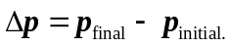
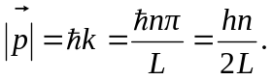
At  the initial momentum at the wall is 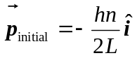 and the final momentum, after turning around, is 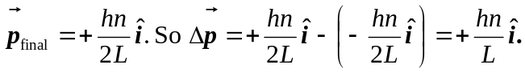
At 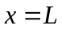 the initial momentum is 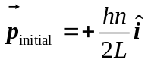 and the final momentum, after
turning around, is 